ASSIGNMENT 2

Before

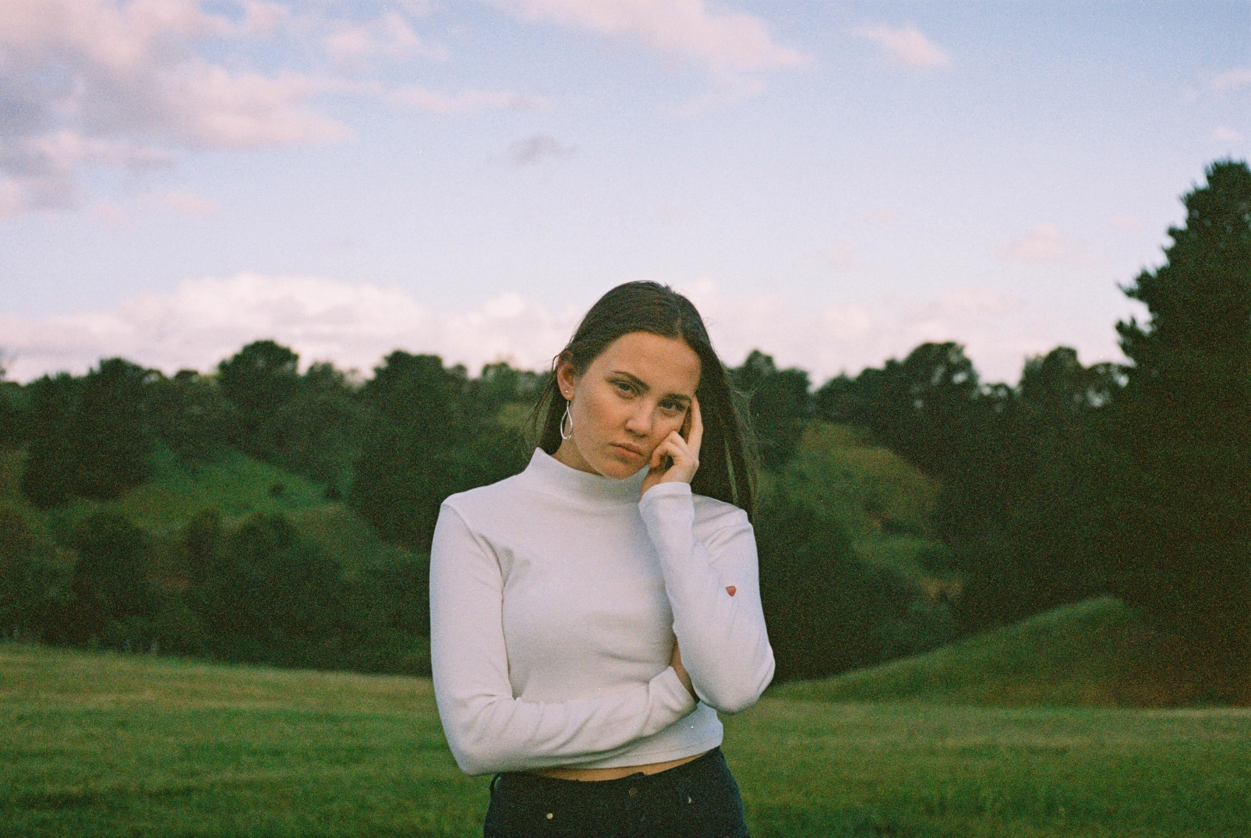

After

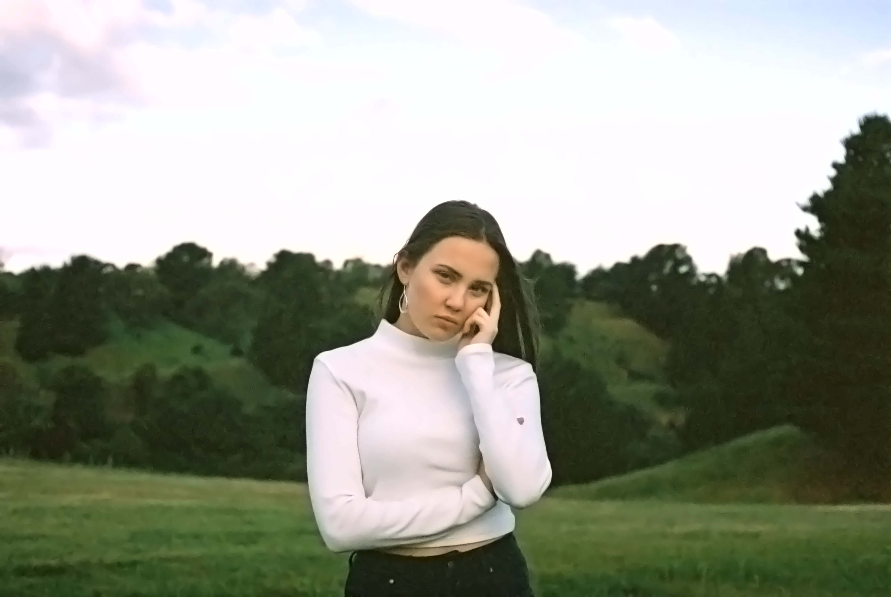

The noise has been removed and changed the color mode to lab. I made some changes in curves and changed the color range also.